DECODELABS: DATA ANALYTICS INTERNSHIP
Project 4: Data Visualization Report

Intern Name: Chisom Promise Onyekaba

Date Submitted: 12th June 2026

Dataset: Cleaned Dataset for Data Analytics (DecodeLabs)

Data Range: Jan 2023 - Jun 2025

Total Rows: 1,200

Total Columns: 14

Tool Used: Power BI Desktop

Dashboard Overview
This dashboard presents 8 visualizations covering revenue performance, order fulfillment, marketing effectiveness, payment behavior and seasonal trends across 1,200 orders totalling $1,264,761.96 in revenue.
Chart types were deliberately varied to match each data story: bar charts for category comparisons, pie/donut charts for proportional breakdowns, line charts for trends over time, and column charts for year-over-year comparisons.

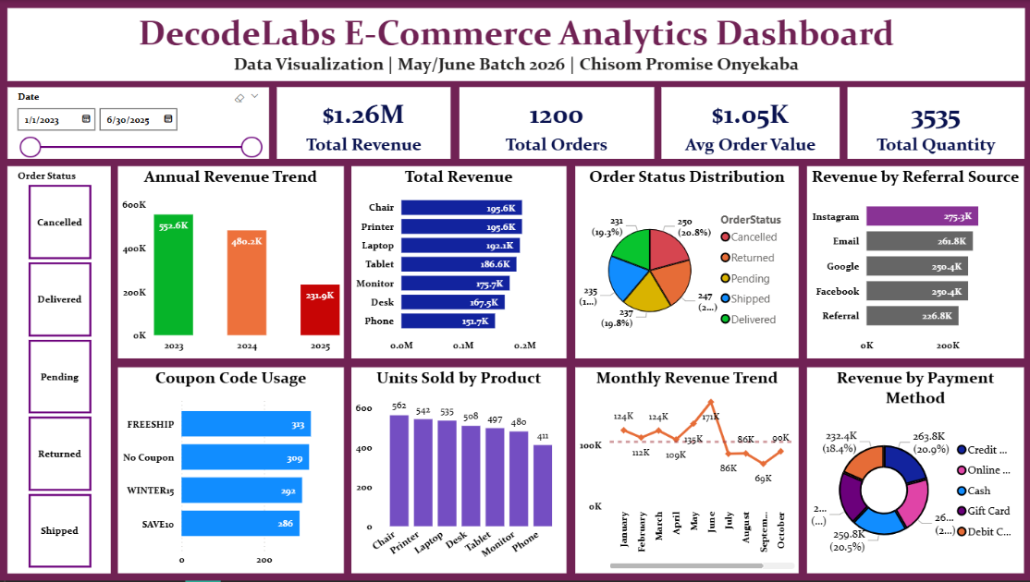

Key Insights
1. Revenue By Product
Printer ($191.1K) and Chair ($188.0K) lead in revenue, while Phone trails at $143.4K; suggesting an opportunity for targeted phone promotions.
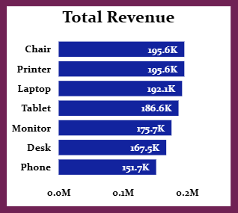

2. Order Status Distribution
Only 19.7% of orders are Delivered. Cancelled (20.9%) and Returned (19.3%) combined represent 40.2% of all orders; a critical fulfillment issue.
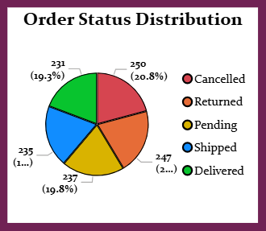

3. Monthly Revenue Trend
Revenue peaks in June ($171K) and drops sharply by September ($69K); a 59% decline. Five months fall below the average line, indicating strong seasonality.
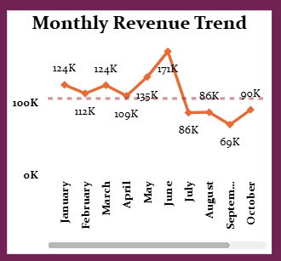

4. Revenue By Referral Source
Instagram leads with $262.8K, while Referral trails at $217.5K. Marketing spend should prioritize Instagram.
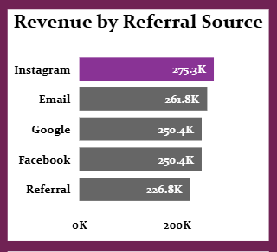

5. Revenue By Payment Method
Credit Card leads at 21.2%, closely followed by Online (18.7%). All 5 methods are fairly balanced; no dominant payment preference.
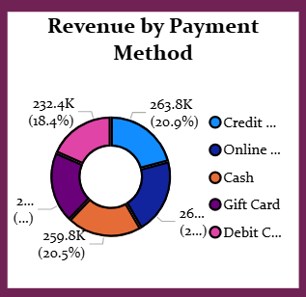

6. Units Sold by Product
Chair leads with 547 units sold, Phone lowest at 387; consistent with its revenue ranking.
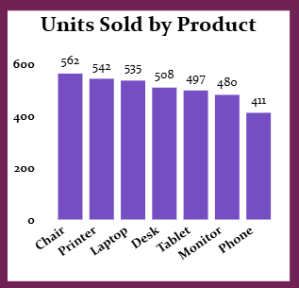

7. Annual Revenue Trend
Revenue declined from $552.6K (2023) to $480.2K (2024); a 13% drop requiring investigation. 2025 ($231.9K) reflects partial-year data only (through June).
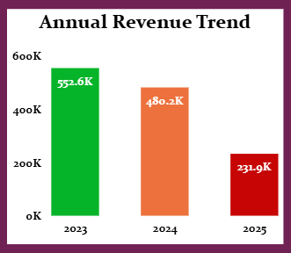

8. Coupon Code Usage
FREESHIP is most redeemed (307 uses), closely followed by No Coupon (300); suggesting free shipping is a stronger incentive than percentage discounts.
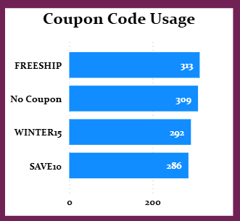

Recommendations
1. Investigate the 40.2% combined Cancelled/Returned rate; the single biggest threat to revenue.
2. Reallocate marketing budget toward Instagram, the top performing referral channel.
3. Plan targeted promotions for low-revenue months (July-September) to flatten seasonal dips.
4. Investigate the 13% YoY revenue decline from 2023 to 2024.
5. Consider replacing percentage-based coupons (SAVE10, WINTER15) with free shipping offers given customer preference for FREESHIP.

